**BMI CALCULATOR**

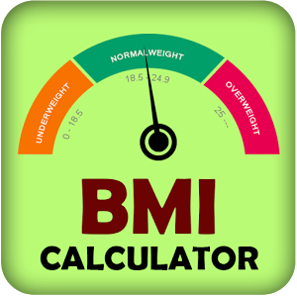

**Introduction:**

**An assembly language is a low-level programming language for microprocessors and other programmable devices. Intermediate-level programming language which is higher (is easier to use but runs slower) than machine language and lower (is more difficult to use but runs faster) than a high-level language such as Basic, Fortan, or Java. Programs written in assembly language are converted into machine language by specialized programs called assemblers or compilers for their execution by the machine (computer).**

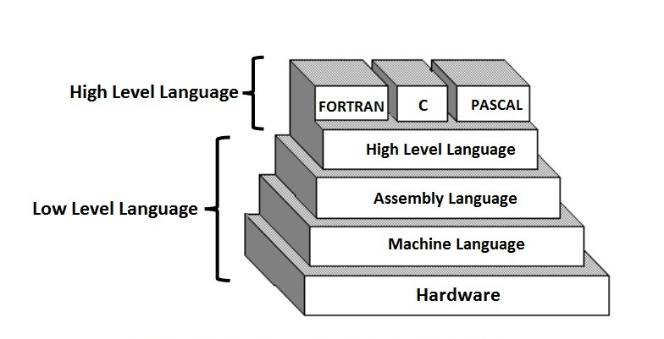

**A program written in assembly language consists of a series of (mnemonic) processor instructions and meta-statements (known variously as directives, pseudo-instructions and pseudo-ops), comments and data. Assembly language instructions usually consist of an**[**opcode**](https://en.wikipedia.org/wiki/Opcode)**mnemonic followed by a list of data, arguments or parameters. These are translated by**[**assembler**](https://en.wikipedia.org/wiki/Assembly_language_assembler)**into [machinelanguage](https://en.wikipedia.org/wiki/Machine_language" \o "Machine language) instructions that can be loaded into memory and executed.**

**Assembly language is used for transforming higher-level programming languages like C into machine code. Processors can only run machine code -- a sequence of short, discrete, instructions encoded in binary format. Every time any program runs, machine code is being executed by a processor.**

**Background:**

**In this project we use some new syntax and the details is given bellows-**

**INT 21h**

* **Here INT 21h is used for getting input.**

**AND AX, 000FH**

* **For converting the character into digit.**

**MUL BX**

* **For multiplying the value of AX with BX.**

**CMP AL, 0DH**

* **For comparing the value of AL with Enter.**

**DIV BX**

* **For dividing the value of AX by BX.**

**We also use a WORD variable SUM.**

**Project Description:**

* **BMI is a way of checking that a person is a healthy weight for their height.**
* **For your height and weight there will be a healthy range which you should fit into, this range is to account for the fact people have different builds and sizes.**

**In this project we input our height(in cm) and weight (in kg) and its show me the result that my weight is OVER or PERFECT or UNDER.**

**In this project basically we had done the work of PUSH, POP,MUL,DIV and other commanding thing like JMP, LOOP, and CMP etc.**

**Now we will discuss about the some important part of our project code.**

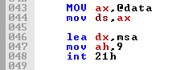

**The above picture is the part of our code, use for print any kind of massage. So we will use this command and print all massage in our project by using this part of code.**

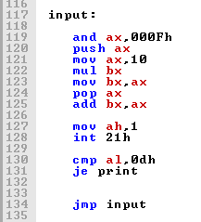

**The above picture is the part of our code, used for any kind of decimal input that is HEGHT of the user in cm.**

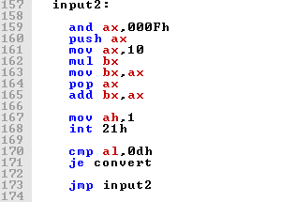

**The above picture is the part of our code, use for 2nd input that is the WEIGHT of the user in kg.**

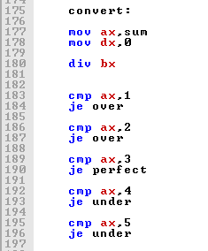

**The above picture is the part of our code, use for conversion, that is the BMI of the user. In the last part of the program we show some instructions for the user. If He or She has Over weight then have some instructions and if He or She has Under weight then have some instructions.**

**Flow chart:**

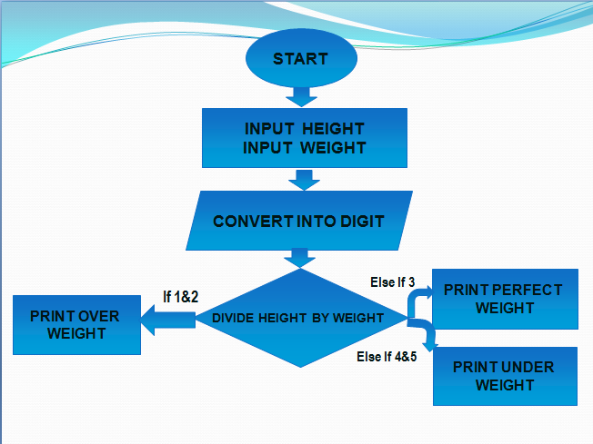

**In this project we use a flow chart in order to understand by a simple human. After seeing the flow chart a non technological man can understand that how to work this calculator.**

**Here first we start from START. Then we gave 2 input one for height and one for weight.**

**Then we finally can see the result after BMI calculation.**

**Experimental Result:**

**In this project we use many things. Emu 8086 like**

* **Ascii code**
* **Loop, jump, cmp, AND etc..**

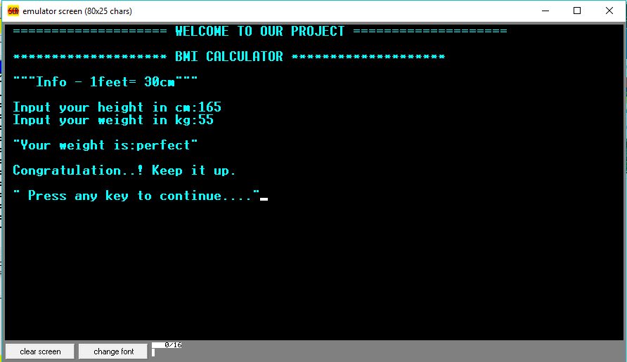

**Here is a short example for perfect weight.**

**Next we can see that there have 2 instructions. After pressing 1 we can see that how can we gain our perfect weight if we are in under weight.**

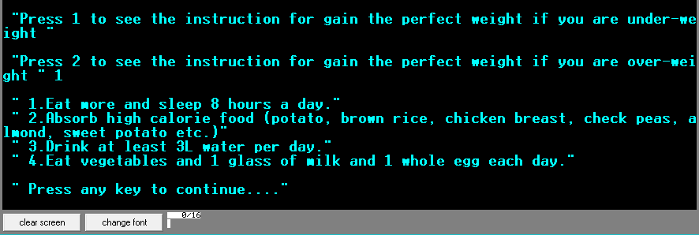

**If we press 2 then we can see that how can we gain our perfect weight if we are in over weight.**

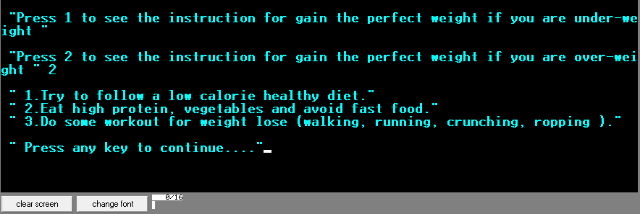

**Advantage:**

* **Easy to calculate.**
* **Easy to Understand.**
* **Inspired to learn more**
* **Inspired to know more**
* **We can find our mass index and take proper steps for keeping fit our body at any time.**

**Disadvantage:**

* **We can't find actual BMI.**
* **This process can't take floating number and can't gave actual weight.**

**Future Work:**

**The BMI calculator provides innumerable opportunities for further investigation into the evolution of a task prioritization sceme within a dynamically changing ,randomly updated environment**

**Conclusion:**

**This project is interesting and helpful. The BMI calculator is inspired to create other calculator. We have completed our project and obtain more experience.**